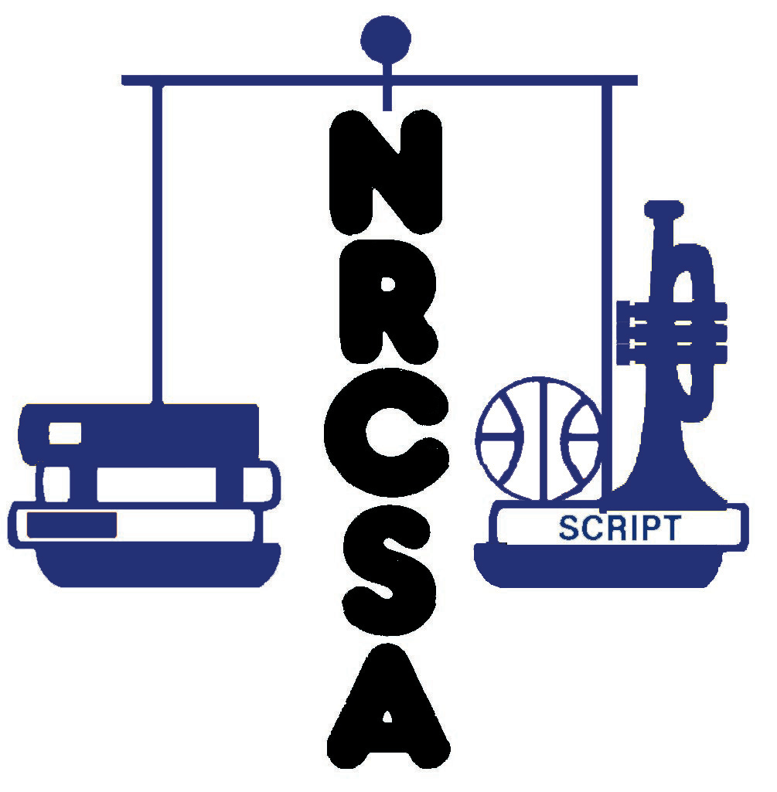
NEBRASKA RURAL COMMUNITY
SCHOOLS ASSOCIATION
SUPERINTENDENT SEARCH SERVICE
455 S. 11TH St., Suite B
Lincoln, NE 68508
(402) 335-7732
superintendentsearch@nrcsa.net

NRCSA SUPERINTENDENT APPLICATION FORM

Please fill in the gray boxes. You can click the box in which you want to type or you can use the ‘Tab’ key to advance to the next box.

Personal Information:

Name: | Home Phone:

Mailing Address: | Work Phone:

City, State, Zip Code: | Cell Phone:

E-mail Address:

How may we contact you? | At work | At home | By E-mail | By Cell Phone:

Current Employment Information:

Are you currently under contract to a school district or educational institution?

If so, can you obtain a release to accept a new position?

Name of District | Location of District | Institution

Your Position

In the space below briefly describe your current school/district/educational institution in terms of organization/mission, enrollment, staff, budget, etc. Also describe your position, experience with the organization, and major duties. (Take as much space as needed, the next page of the application will be forced onto a new page)

NEBRASKA RURAL COMMUNITY SCHOOLS ASSOCIATION
SUPERINTENDENT SEARCH SERVICE

NRCSA SUPERINTENDENT APPLICATION FORM

Certification

Nebraska Certificate Type: | Expiration:

Endorsements:

Certificates/Endorsements From Other States:

Please attach a copy of your current Nebraska certificate OR provide evidence of eligibility for a Nebraska certificate endorsed for the Superintendency. Eligibility for a provisional endorsement is acceptable.

Educational/Professional Training (Begin with undergraduate degree, there is no need to eliminate the blanks in this section)

Institution/Location | Degree Earned | Date Granted

Educational Work Experience

Institution/Location | Dates (From/To) | Position/Duties

NEBRASKA RURAL COMMUNITY SCHOOLS ASSOCIATION
SUPERINTENDENT SEARCH SERVICE

NRCSA SUPERINTENDENT APPLICATION FORM

Other Professional Experience

Institution/Location | Dates (From/To) | Position/Duties

Memberships in Professional Organizations

Professional Achievements/Awards/Honors

References
Please list below the names and contact information for your current supervisor (if currently a Superintendent list your Board President) and three additional persons who have knowledge of your professional skills and character and who will provide a reference for you. These are in addition to the three current letters of recommendation to be submitted with your application.

Current Supervisor Name: | Position:
E-mail address: | Phone:

Additional References

Reference 1 Name: | Reference 1 Position:
Reference 1 E-mail address: | Reference 1 Phone:

Reference 2 Name: | Reference 2 Position:
Reference 2 E-mail address: | Reference 2 Phone:

Reference 3 Name: | Reference 3 Position:
Reference 3 E-mail address: | Reference 3 Phone:

NEBRASKA RURAL COMMUNITY SCHOOLS ASSOCIATION
SUPERINTENDENT SEARCH SERVICE

NRCSA SUPERINTENDENT APPLICATION FORM

Candidate Statements (Use additional pages as necessary)

- Please provide a brief autobiography.

- Please provide a personal statement describing your major educational accomplishments and the specific leadership and management skills you can bring to the Superintendency of the client school district.

- Provide any additional information you believe would assist the Board in evaluating your candidacy.

