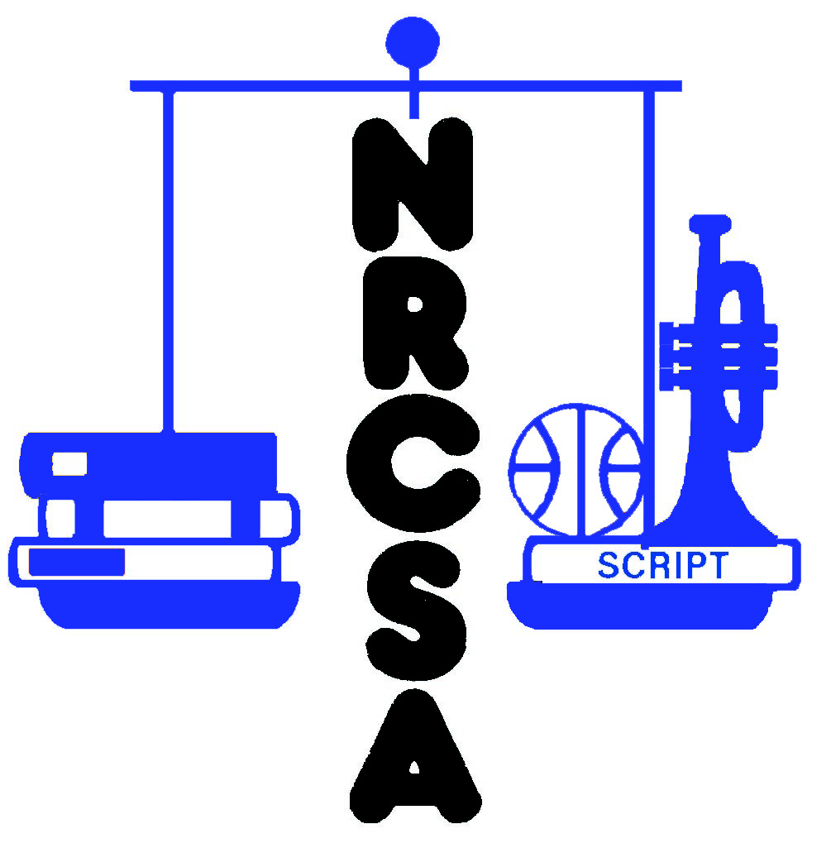
Nebraska Rural Community Schools Association

NRCSA Spring Conference
March 18 - 20, 2026
Crowne Plaza & Younes North Convention Center

Registration Form

School or Institution Name:

District Phone No: |  | Contact Person:

Address: |  | City: |  | Zip:

Contact Person e-mail Address:

_____________________________________________________________________________________

Pre-Conference Leadership Seminar – 10:00 AM Wednesday, March 18, 2026

Seven Habits of Highly Effective People brought to you by:

Registrant’s Full Name | Name for Nametag | Wednesday Lunch  3-18-26
_{Example}  John Smith | John | X

This pre-conference leadership seminar by FranklinCovey is free for NRCSA members but space is limited to the first 150 registrants.

_____________________________________________________________________________________

_____________________________________________________________________________________

2026 NRCSA Spring Conference – March 19 & 20, 2026

Please register ONLY for the meals the registrant will attend

**Note: Meal Fees are included in Conference Fees**

Registrant’s Full Name | Name for Nametag | Conference Fees:  $250.00 – Member  $400.00 – Non-Member | Thursday Lunch  3-19-26 | Thursday Dinner  3-19-26 | Friday Brunch  3-20-26 | Total
_{Example}  John Smith | John | $250.00 | X | X | X | $250.00

Spouses/Guests Additional Meals for Spouses or Guests |  |  |  | $30.00 | $25.00 | $23.00 | Total
 |  | No Conf Fee Needed | No Conf Fee Needed
 |  | No Conf Fee Needed | No Conf Fee Needed
 |  | No Conf Fee Needed | No Conf Fee Needed

Make Checks Payable to: NRCSA Total Enclosed:

Mail or Fax Registrations To:
NRCSA Spring Conference
440 S. 13th St, Ste B
Lincoln, NE 68508
DEADLINE FOR FULL REFUNDS: March 13
Fax: (402) 476-7740

Or register on-line at: www.nrcsa.net

_____________________________________________________________________________________

When planning for a large event (i.e. NRCSA Spring Conference or NRCSA Legislative Forum), NRCSA must make financial commitments such as facility rental and costs of meals. Weather sometimes causes a decision to be made by NRCSA in the form of a cancellation or postponement of the event, or for registrants to decide whether or not they can attend the event. Sometimes registrants need to make a decision not to attend due to other reasons. NRCSA has weighed the issues of its financial commitments versus registrants not being able to attend for various reasons. Thus, the following policy has been adopted:

WEATHER CANCELLATION DECISION MADE BY NRCSA:

All registrants, including vendors, will be offered a full refund or to have the registration fee carried forward to the next year’s event.

WEATHER POSTPONEMENT DECISION MADE BY NRCSA:

All registrants, including vendors, will be offered a full refund or to have the registration fee carried forward to the re-scheduled event.

DECISION BY A REGISTRANT, INCLUDING VENDORS, TO NOT ATTEND THE EVENT AND COMMUNICATED TO NRCSA AT LEAST A WEEK PRIOR TO THE EVENT:

Two options will be provided to the registrant, including vendors: A full refund OR carry the registrant amount forward to the following year.

DECISION BY A REGISTRANT, INCLUDING VENDORS, TO NOT ATTEND THE EVENT AND COMMUNICATED TO NRCSA WITHIN A WEEK PRIOR TO THE EVENT:

For members, an option will be provided to have the registration fee carried forward to the next year’s event OR a refund minus the costs to NRCSA for meal(s). (NOTE: In 2026, for the Spring Conference this would be $105, for the Legislative Forum the cost is $45.)

For vendors, the option to carry the registration amount to the following year will be provided.

DECISION BY A REGISTRANT TO NOT ATTEND THE EVENT, BUT FAILS TO COMMUNICATE WITH NRCSA PRIOR TO THE EVENT:

No refund will be provided.

